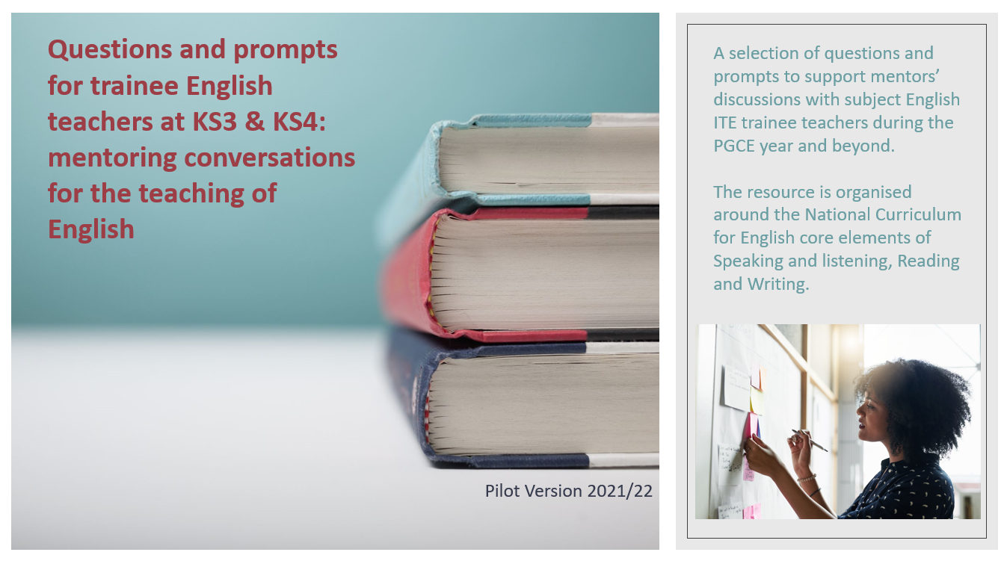
Speaking and Listening
 | Early/Middle ITE | Middle/Later ITE | Later ITE/ECT
The quality and variety of language that pupils hear and speak are vital for developing their vocabulary and grammar and their understanding for reading and writing | What impact does questioning have on pupils’ thinking? How would you structure a sequence of questions to prompt deeper thinking?  Evidence is seen of student teacher asking questions that promote deeper thinking. | Are you aware of your vocabulary when asking questions? Do you support students to ask questions of you and of each other?  Evidence is seen that student the teacher is encouraging alternate ways to articulate thinking verbally through supporting interaction. | How would you design a ‘pens down’ or ‘SALAD’ (Speaking and Listening and Discussion) lesson?  Evidence is seen of confidence managing students’ behaviour that enables them to explore concepts and apply knowledge in open discussion,
 | How do you support development of vocabulary and lexical curiosity in your classroom?  Evidence is seen of opportunities for pupils to develop vocabulary (being curious/asking questions/not being afraid to ‘get it wrong’). | How are you supporting students to explore their ideas through interaction?  Evidence is seen that the trainee teacher is encouraging students to take part in exploratory talk and is setting an ethos for talk. | How does discussion support students’ thinking?  Evidence of opportunities to develop students’ capacity to explain their understanding of books and other reading; students are assisted in making their thinking clear to themselves as well as to others
 | Are students supported to present their ideas verbally?  Evidence that pupils have the confidence to present ideas and to critique ideas of others. | Do students have opportunities for formal presentations and debate?  Lesson design incorporates ‘outward facing’ articulation by students. | How do you approach drama and performative poetry?  Evidence that students are improvising, rehearsing and performing play scripts and poetry in order to generate languages and discuss language use and meaning,

Reading
 | Early/Middle ITE | Middle/Later ITE | Later ITE/ECT
Reading widely across both fiction and non-fiction supports development of students’ knowledge of themselves and the world they live in and helps to establish an appreciation and love of reading, | Are you modelling the enjoyment of reading?  Can students see examples of your own reading? Do you share your enthusiasm? | Are you confident to support students to challenge and expand their own reading preferences?  Evidence that students are supported to explore a variety of reading including whole books, short stories, poems and plays with a wide coverage of genres, historical periods, forms and authors, | Do you support re-reading and re-visiting of texts to refine understanding and appreciation?  Evidence that students appreciate the value of re-reading books encountered earlier to increase familiarity with them and provide a basis for making comparisons.
 | What support do you give for encounters with new or challenging vocabulary in texts?  Students are learning new vocabulary, relating it explicitly to known vocabulary and understanding it with the help of context, dictionaries and discussion. | How do you support explicit comprehension of how form supports meaning in texts?  Evidence that students know how language, including figurative language, vocabulary choice, grammar, text structure and organisational features, presents meaning. | How do you encourage students to be critical readers?  Students are able to articulate what they like about texts and why, and can make informed, critical judgements about the value for them of different texts.
 | How do you introduce poetry and dramatic texts to your students?  Students show emerging appreciation of a range of poetic and dramatic conventions and understanding how these have been used. | Are you confident to support and model dramatic reading of texts?  Students exhibit an emerging understanding of how the work of dramatists and poets is communicated effectively through performance. | How do you support exposure of your students to live readings and performances?  Evidence that students are aware of the immediacy of performative texts, how alternative staging allows for different interpretations of a play or how reading aloud of a poem can influence emotional response.
Writing
 | Early/Middle ITE | Middle/Later ITE | Later ITE/ECT
Effective writing involves the articulation, organisation, and communication of ideas, showing awareness of audience, sensitivity to purpose and context and confident knowledge of vocabulary and grammar | How do you support students to choose the most effective and most appropriate form for their writing? Are they encouraged to experiment?  Evidence is seen that students are able to apply their growing knowledge of vocabulary, grammar and text structure to their writing and to select an appropriate form for the task. | Are you supporting the students’ knowledge acquired through their reading and discussion into their written work?  Students are drawing on their knowledge of literary and rhetorical devices from their reading and listening to enhance the impact of their writing. | Are you supporting your students to write for real-world audiences?  Evidence is seen that students are able to write accurately, fluently, effectively for a wide range of purposes and audiences.
 | How are you supporting your students to be critical in their assessment of writing (their own and that of others)?  Evidence is seen that students are considering how effectively their writing reflects the audiences and purposes for which it was intended. | Are you supporting the use of techniques such as free-writing, mind-mapping and drafting to support your students to be confident independent writers?  Students are confident amending the vocabulary, grammar, and structure of their writing to improve its coherence and overall effectiveness. | Are you encouraging a love of writing?  Students are learning to write at length for pleasure and for their own purposes.
 | How are you contextualising grammatical constructions gleaned from students’ reading and listening into their writing development?  Evidence is seen that students are drawing on new vocabulary and literary devices, using these consciously in their writing and speech to achieve particular effects | Are you encouraging meta-cognition of writing skills?  Students are confident discussing reading, writing and spoken language with precise and confident use of linguistic and literary terminology. | Are you supporting the correct use of Standard English in students’ writing, while still exhibiting respect for their own cultural and linguistic heritage?  Students can use Standard English confidently in their own writing and speech. Evidence is seen that students know and understand the differences between spoken and written language, including differences associated with formal and informal registers, and between Standard English and other varieties of English.

